***2024 Missions Giving Christmas Market***

***Be the Light!***

**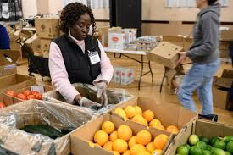 *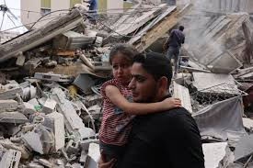***

***Brookline Food Pantry Doctors Without Borders - Gaza***

**The *Missions Giving Committee* will *MATCH***

**donationsto these organizations.**

* Scan the QR code to complete the form and give online, or visit https://www.unitedparishbrookline.org/news/missions-giving-christmas-market-2024/.
* Or mail one check and form to the United Parish office.
* The United Parish will MATCH and distribute donations.

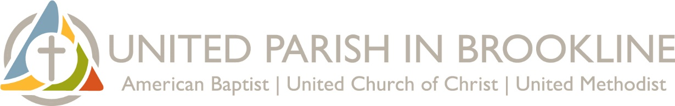

**Hope in the power of GOOD!**

The 8 organizations in this brochure are helping

locally, nationally, or internationally.

“We only have what we give.”

* Isabel Allende

**Christmas 2024, let’s be the hope!**

**Agape Global Health for Haiti**

The small Haitian island of La Gonave, where Agape is located, is facing an influx of displaced people escaping the violence and instability in Port-au-Prance. Prices for nearly everything are skyrocketing. They need support more than ever.

Agape brings hope through:

* **The Agape Clinic** 
  + A health clinic specializing in prenatal and newborn care.
* **Menstrual Health Education**
  + Teaching girls and women about their bodies and menstruation.
  + Providing washable, reusable menstrual kits empowering girls to stay in school when they’re menstruating.
* **Clean Water Access**
  + Training and equipping women to clean water using high-efficiency filtration systems to supply safe drinking water to families.

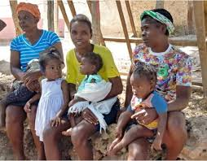

Doctors from the Boston medical community – including a parishioner from United Parish in Brookline – have traveled to help at Agape to provide assistance and training.

**Gift #1: Agape Global Health for Haiti**

**Brookline Food Pantry**

None of our neighbors should go to bed hungry.

In August 2021, the *Brookline Food Pantry* moved its headquarters into United Parish in Brookline. *The* *Food Pantry* now works out of three locations: our church; High St. Veterans Community Room at 226 High Street; and a Boston Housing Authority residence.

People accessing food are every age and background, including children and seniors, recent immigrants and longtime residents, the well and the disabled.

The *Brookline Food Pantry* also gives free take-home weekend meal packs to **school-age children** in need.

United Parish is proud to have supported the *Brookline Food Pantry* for decades through monthly food collections, the Walk for Hunger*,* and other financial support.

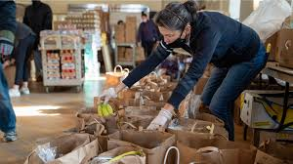

Contact [brooklinefoodpantry@gmail.com](mailto:brooklinefoodpantry@gmail.com) to **volunteer** throughout the year.

**Gift #2: Brookline Food Pantry**

**Dhansa Maweni School, Kenya**

A school for local **children, ages three to fourteen**, whose families cannot afford public school fees. Four teachers and a maintenance worker have come together to help children have a better chance of **lifting themselves out of poverty**. Children study math, science, Christian religious education, English, Swahili, creative arts and physical education. Staff strive to feed the children physically, academically, and spiritually.

Staff and students are dedicated. Their work goes a long way. So do donations to this visionary school.

* $25 pays one week of a teacher’s salary.
* $50 provides one year of a student’s school supplies.
* $100 provides one month of breakfast porridge.

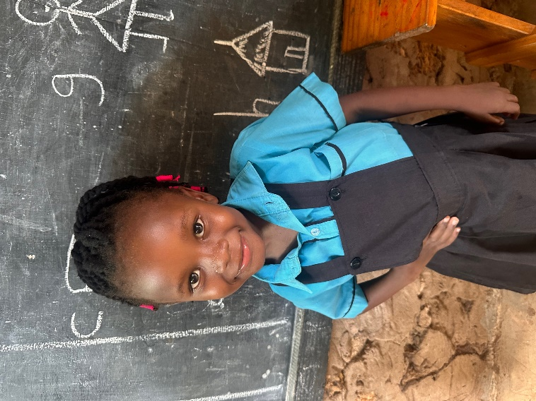 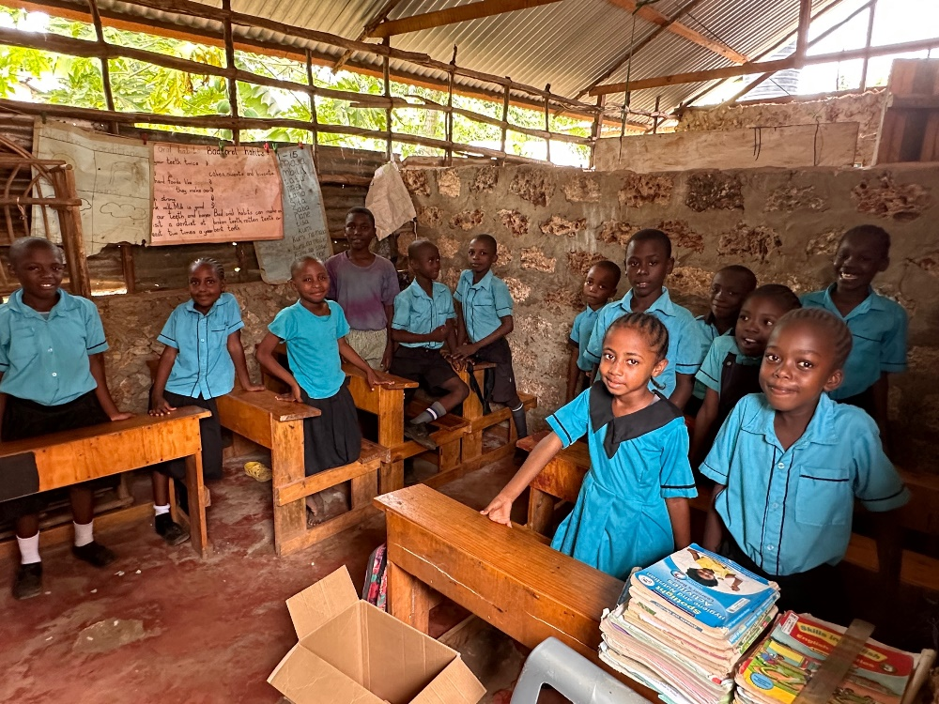

**Gift #3: Dhansa Maweni School, Kenya**

**Doctors Without Borders**

The United Parish Missions Giving Committee has been supporting *Doctors Without* *Borders* (also known as *Medecines Sans Frontieres*) for years. They are a proven agency with a track record of helping people in the most dangerous parts of the world.

They provide services in the midst of conflict because they observe neutrality and impartiality in the name of universal medical ethics and the right to humanitarian assistance.

*Doctors Without Borders* works in more than 70 countries.

The needs today are dire. In their words, “MSF activities in pediatric, neonatal, and obstetric care are just a drop in the ocean of medical needs in Gaza.” But *Doctors Without Borders* is there, will continue being there, and are positioned to expand services when possible.

Your support for *Doctors* *Without Borders* (MSF) helps assure people in places like Gaza, Sudan and Syria that they’re not forgotten.

Be part of the team that delivers hope.

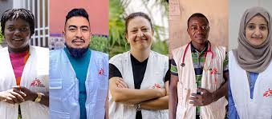

**Gift #4: Doctors Without Borders**

**Horizons for Homeless Children**

Combating the effects of homelessness becomes an even more pressing and critical mission when children are involved. *Horizons for Homeless Children* is leading the fight in Massachusetts to help alleviate the trauma and stress of homelessness on both children and their families. They provide high-quality early education, vital opportunities for play, support for parents, and crucial advocacy on behalf of some of our most marginalized neighbors.

Support for *Horizons for Homeless Children* provides essential:

* Early education
* Help and support for parents
* Play in shelter
* Advocacy

~~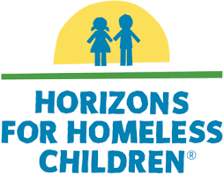~~ 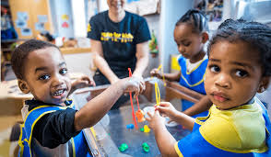

**Gift #5: Horizons for Homeless Children**

**Louis D. Brown Peace Institute**

15-year-old Louis was caught in fatal crossfire near his home in Dorchester in 1993 when there were no resources in Boston for survivors of homicide victims.

Louis’ murder was high-profile. The media speculated about why a teenager had been murdered in broad daylight. Was he in a gang? Was it a drug deal gone bad? When it was reported that Louis was, in fact, an honor student killed on his way to a *Teens Against Gang Violence* meeting, there was a major shift in public opinion and an outpouring of support.

Louis’ mother co-founded the LDBPI in 1994 to honor Louis’ legacy and continue the peacemaking work he led.

The work of the LDBPI began with **The Peace Curriculum** to teach the value of peace to students and ways to deal with murder, trauma, grief and loss. The Peace Curriculumwas recognized by the United States Dept. of Justice for its contribution to Boston’s juvenile crime reductions, and as an innovative and effective primary prevention strategy in the report One City’s Success Story.

The healing and life-changing work of LDBPI includes:

* Survivor Outreach Services
* Community Reentry Services Program
* Healing Support Services
* Mother’s Day Walk for Peace
* The Louis D. Brown Day of Civic Engagement, recognized by the City of Boston

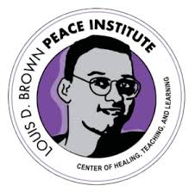

**Gift #6: Louis D. Brown Peace Institute**

**Native American Boarding School Healing Coalition**

The social, emotional, spiritual, and cultural devastation from forced boarding schools has been passed down to Native American individuals, families, communities, and Tribal Nations.

Baptist, Congregational and Methodist churches historically sponsored these boarding schools. Once, we were part of the problem*.* **Today, let’s be part of the healing.**

Until the1970’s, some Native American children were abducted by government agents and sent to boarding schools. Children were beaten, starved or otherwise abused when they spoke their native languages. It’s estimated that there were 500 boarding schools. The objective of the schools was to “kill the Indian and save the man.”

*The Native American Boarding School Healing Coalition* works for **truth, healing** and **justice** for boarding school survivors and descendants.

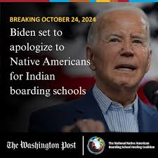 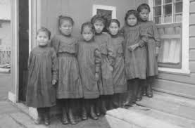

**Gift #7: Native American Boarding School Healing Coalition**

See NABSHC [free lesson plans](http://boardingschoolhealing.org/curriculum) for elementary, middle, and high school teachers.

NABSHC [online database](http://boardingschoolhealing.org/resource-database-center/) of educational resources.

Watch a [PBS News Hour report](https://www.youtube.com/watch?v=z0xRni69e_c) about Native American Boarding Schools and NSBSHC.

**Youth Enrichment Services (YES)**

The mission of *Youth Enrichment Services* (YES) is to inspire youth through outdoor experiences and leadership opportunities that build confidence and prepare them to summit life’s challenges.

YES engages youth through a unique three-tiered ladder of programs which support and challenge them throughout elementary, middle, and high school. As they move through the progressively challenging tiers, youth develop confidence and gain valuable life skills. They learn how to stay active, set goals, be confident, make healthy choices, act as community leaders, and succeed in college.

Experiences include rock climbing, surfing, mountain biking, kayaking, track and field, ski and snowboarding.

YES is recommended by some youth at United Parish in Brookline.

***~~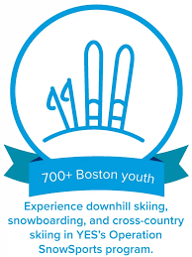~~*** 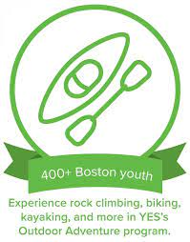 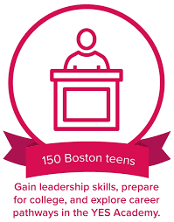

**Gift #8: Youth Enrichment Services**

**United Parish in Brookline**

***Missions Giving***

United Parish Missions Giving is committed to financially supporting organizations doing good work locally, nationally and internationally.

Funds come from three sources:

* **Interest** from the United Parish church **endowment.**
* Roughly **10% of all pledges** to United Parish goes to Missions Giving and other philanthropic efforts.
* Specific **offerings** in church services.

Missions Giving also *supplements*, *matches*, *doubles* or *triples* the amounts raised by congregants involved in church-sponsored initiatives, such as the **Negro Spiritual Royalties Project** and **Walk for Hunger.**

“Where your treasure is, your heart will be also.”

– Matthew 6:21

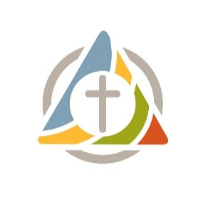United Parish in Brookline

Missions Giving Christmas Market 2024

Order Form

|  |  |  |
| --- | --- | --- |
|  | Organization | Dollar Amount |
| Gift #1 | Agape Global Health for Haiti |  |
| Gift #2 | Brookline Food Pantry |  |
| Gift #3 | Dhansa Maweni School, Kenya |  |
| Gift #4 | Doctors Without Borders |  |
| Gift #5 | Horizons for Homeless Children |  |
| Gift #6 | Louis D. Brown Peace Institute |  |
|  |  |  |
| Gift #7 | Native American Boarding School Healing Coalition |  |
| Gift #8 | Youth Enrichment Services |  |
|  | Additional Donation to Missions Giving |  |
| **Grand Total** | |  |

(To fill out the above form online, please click [here](https://forms.gle/EfqnvGEBdVNDjz6v6) or scan the QR code.)

* Give online at [unitedparishbrookline.org/give](https://www.unitedparishbrookline.org/giving-stewardship).
  + Click the green “Make a Donation” button.
  + Enter your total amount next to “Special Gift Christmas Mission Market.”
* Or mail one check and form to the United Parish office.

The United Parish will match and distribute donations.

Name ___________________________________

Phone ___________________________________

Email ____________________________________

____ Cash

____ Credit

____ Check (Payable to United Parish in Brookline. Memo: Missions Giving Christmas Market)

____ Venmo (Search @unitedparishinbrookline on the app)

____ PayPal (Visit [PayPal.me/unitedparish](https://paypal.me/unitedparish) or search [office@upbrookline.org](mailto:office@upbrookline.org) on the app)